**PROGRAM:**

**App.vue**

<template>

<div id="app">

<header>

<h1>Image Gallery</h1>

</header>

<main>

<ImageGallery />

</main>

</div>

</template>

<script>

import ImageGallery from './components/ImageGallery.vue';

export default {

components: {

ImageGallery

}

};

</script>

<style>

*{

background: antiquewhite;

}

#app {

font-family: Avenir, Helvetica, Arial, sans-serif;

text-align: center;

color: #2c3e50;

margin-top: 60px;

}

header {

color: rgb(15, 116, 163);

padding: 1rem;

}

header h1 {

margin: 0;

}

main {

padding: 1rem;

}

</style>

**ImageGallery.vue**

<template>

<div class="gallery">

<input type="file" id="fileInput" @change="uploadImage" accept="image/*" />

<label for="fileInput" class="upload-btn">Upload Image</label>

<div class="gallery-grid">

<ImageItem

v-for="(image, index) in images"

:key="image.id"

:image="image"

@click="openModal(image, index)"

/>

</div>

<ImageModal

v-if="isModalOpen"

:image="activeImage"

:images="images"

:currentIndex="currentImageIndex"

@close="closeModal"

@change-image="changeImage"

@delete="deleteImage"

/>

</div>

</template>

<script>

import ImageItem from './ImageItem.vue';

import ImageModal from './ImageModal.vue';

export default {

components: { ImageItem, ImageModal },

data() {

return {

images: [

{ id: 1, title: 'Sunset', url: require('@/assets/sunset.png'), description: 'A beautiful sunset', dateUploaded: '2024-08-01' },

{ id: 2, title: 'Mountains', url: require('@/assets/mountains.png'), description: 'Majestic mountains', dateUploaded: '2024-08-05' },

{ id: 3, title: 'Moon', url: require('@/assets/moon.png'), description: 'A serene moon', dateUploaded: '2024-08-12' }

],

isModalOpen: false,

activeImage: null,

currentImageIndex: 0

};

},

methods: {

uploadImage(event) {

const file = event.target.files[0];

if (file) {

const reader = new FileReader();

reader.onload = (e) => {

const newImage = {

id: Date.now(),

url: e.target.result,

title: file.name,

description: prompt('Enter a description for the image:') || 'No description',

dateUploaded: new Date().toISOString().split('T')[0]

};

this.images.push(newImage);

};

reader.readAsDataURL(file);

}},

openModal(image, index) {

this.activeImage = image;

this.currentImageIndex = index;

this.isModalOpen = true;

},

closeModal() {

this.isModalOpen = false;

this.activeImage = null;

this.currentImageIndex = 0;

},

changeImage(index) {

this.activeImage = this.images[index];

this.currentImageIndex = index;

},

deleteImage(index) {

if (confirm('Are you sure you want to delete this image?')) {

this.images.splice(index, 1);

if (this.currentImageIndex === index) {

this.closeModal();

} else if (this.currentImageIndex > index) {

this.currentImageIndex--;

}}}}

};

</script>

<style scoped>

.gallery {

padding: 2rem;

text-align: center;

}

#fileInput {

display: none;

}

.upload-btn {

display: inline-block;

padding: 0.75rem 1.5rem;

background-color: #6db8cf;

color: white;

border: none;

border-radius: 4px;

cursor: pointer;

font-size: 1rem;

margin-bottom: 1rem;

transition: background-color 0.3s, transform 0.2s;

}

.gallery-grid {

display: grid;

grid-template-columns: repeat(auto-fill, minmax(200px, 1fr));

gap: 1rem;

}

.gallery-grid img {

width: 100%;

height: auto;

border-radius: 4px;

box-shadow: 0 4px 8px rgba(0, 0, 0, 0.2);

transition: transform 0.3s;

}

.gallery-grid img:hover {

transform: scale(1.05);

}

</style>

**ImageModal.vue**

<template>

  <div class="modal" @click.self="closeModal">

    <div class="modal-content">

      <img :src="image.url" :alt="image.title" :style="{ transform: `scale(${scale})` }" />

      <button

        v-if="!isFirstImage"

        class="prev"

        @click="prevImage">

        Previous

      </button>

      <button

        v-if="!isLastImage"

        class="next"

        @click="nextImage">

        Next

      </button>

      <div class="bottom-controls">

        <button class="zoom-out" @click="zoomOut">Zoom Out</button>

        <button class="zoom-in" @click="zoomIn">Zoom In</button>

        <button class="delete" @click="deleteImage">Delete</button>

        <button class="metadata-toggle" @click="toggleMetadata">Metadata</button>

      </div>

      <button class="close" @click="closeModal">Close</button>

      <div v-if="showMetadata" class="metadata-info">

        <p class="title">{{ image.title }}</p>

        <p class="description">{{ image.description }}</p>

        <p class="date">{{ image.dateUploaded }}</p>

      </div>

    </div>

  </div>

</template>

<script>

export default {

  props: {

    image: Object,

    images: Array,

    currentIndex: Number

  },

  data() {

    return {

      scale: 1,

      showMetadata: false

    };

  },

  computed: {

    isFirstImage() {

      return this.currentIndex === 0;

    },

    isLastImage() {

      return this.currentIndex === this.images.length - 1;

    }

  },

  methods: {

    closeModal() {

      this.$emit('close');

    },

    prevImage() {

      if (this.isFirstImage) return;

      const prevIndex = this.currentIndex - 1;

      this.$emit('change-image', prevIndex);

    },

    nextImage() {

      if (this.isLastImage) return;

      const nextIndex = this.currentIndex + 1;

      this.$emit('change-image', nextIndex);

    },

    zoomIn() {

      this.scale = Math.min(this.scale + 0.1, 3);

    },

    zoomOut() {

      this.scale = Math.max(this.scale - 0.1, 1);

    },

    deleteImage() {

      if (confirm('Are you sure you want to delete this image?')) {

        this.$emit('delete', this.currentIndex);

      }

    },

    toggleMetadata() {

      this.showMetadata = !this.showMetadata;

    }

  }

};

</script>

<style scoped>

.modal {

  position: fixed;

  top: 0;

  left: 0;

  width: 100%;

  height: 100%;

  background: rgba(0, 0, 0, 0.8);

  display: flex;

  justify-content: center;

  align-items: center;

}

.modal-content {

  position: relative;

  max-width: 90vw;

  max-height: 90vh;

  display: flex;

  flex-direction: column;

  align-items: center;

}

img {

  max-width: 100%;

  max-height: 100%;

}

button {

  position: absolute;

  background-color: rgba(0, 0, 0, 0.7);

  color: white;

  border: none;

  cursor: pointer;

  padding: 0.5rem 1rem;

  z-index: 10;

}

.close {

  top: 1rem;

  right: 1rem;

}

.prev {

  left: 1rem;

  top: 50%;

  transform: translateY(-50%);

}

.next {

  right: 1rem;

  top: 50%;

  transform: translateY(-50%);

}

.bottom-controls {

  position: absolute;

  bottom: 1rem;

  display: flex;

  justify-content: center;

  gap: 1rem;

  width: 100%;

}

.zoom-in,

.zoom-out {

  background-color: rgba(0, 0, 0, 0.7);

  padding: 0.5rem 1rem;

}

.zoom-out {

  margin-left: 10%;

}

.zoom-in {

  margin-right: 10%;

}

.delete {

  position: absolute;

  bottom: 0;

  right: 1rem;

  background-color: rgba(255, 0, 0, 0.7);

}

.metadata-toggle {

  position: absolute;

  bottom: 1rem;

  left: 1rem;

}

.metadata-info {

  position: absolute;

  bottom: 4rem;

  left: 0;

  right: 0;

  padding: 4px;

  background: antiquewhite;

  color: #000000;

  text-align: center;

  border-radius: 4px;

  width: 20%;

}

.title {

  font-weight: bold;

}

.description {

  margin: 0.5rem 0;

}

.date {

  font-size: 0.8rem;

}

button:disabled {

  cursor: not-allowed;

  background-color: rgba(0, 0, 0, 0.5);

}

</style>

**ImageItem.vue**

<template>

  <div class="image-item" @click="$emit('click')">

    <img :src="image.url" :alt="image.title" />

  </div>

</template>

<script>

export default {

  props: {

    image: Object

  }

};

</script>

<style scoped>

.image-item {

  position: relative;

  cursor: pointer;

}

.image-item img {

  width: 100%;

  height: auto;

  border-radius: 4px;

}

</style>

**OUTPUT:**

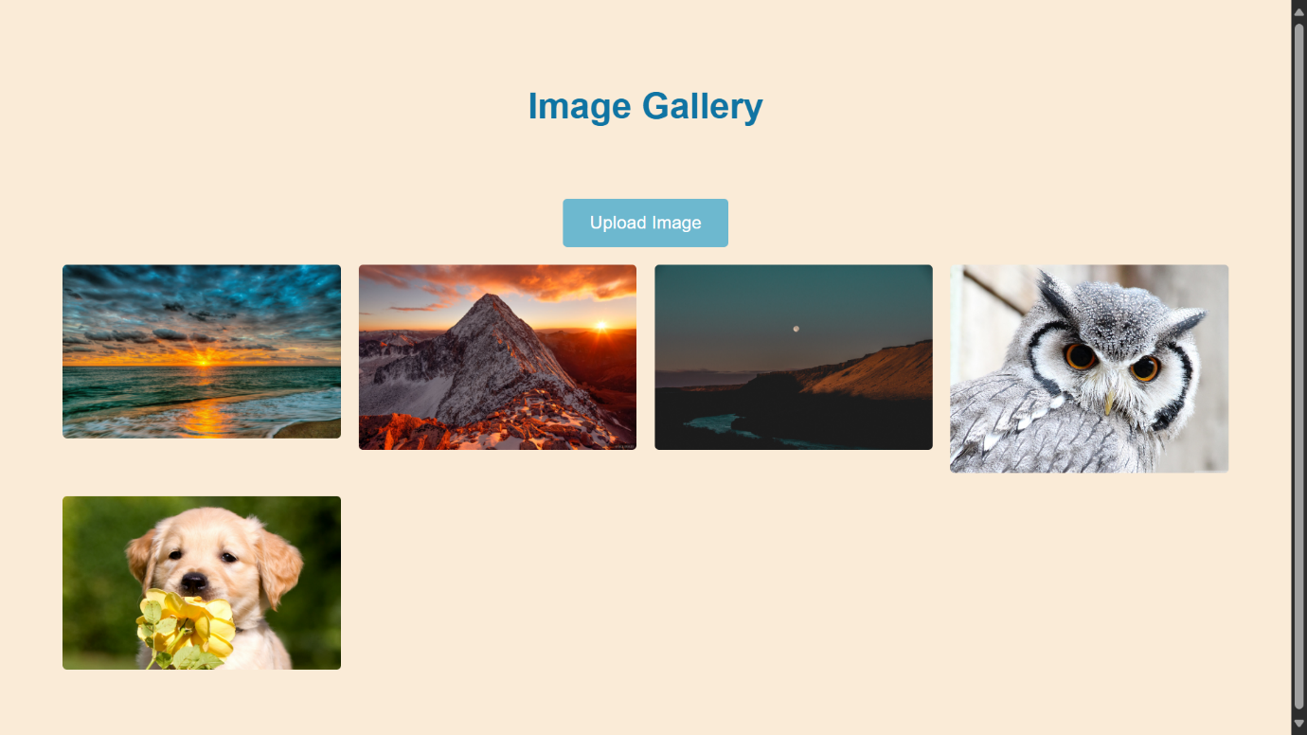Image Gallery**:**

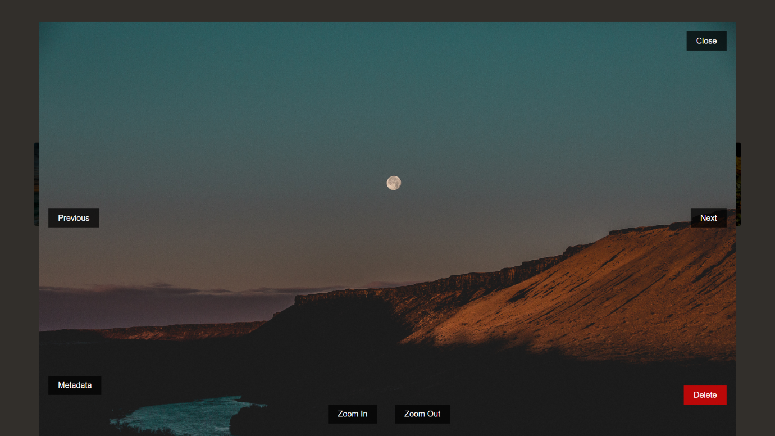Enlarged view of an image:

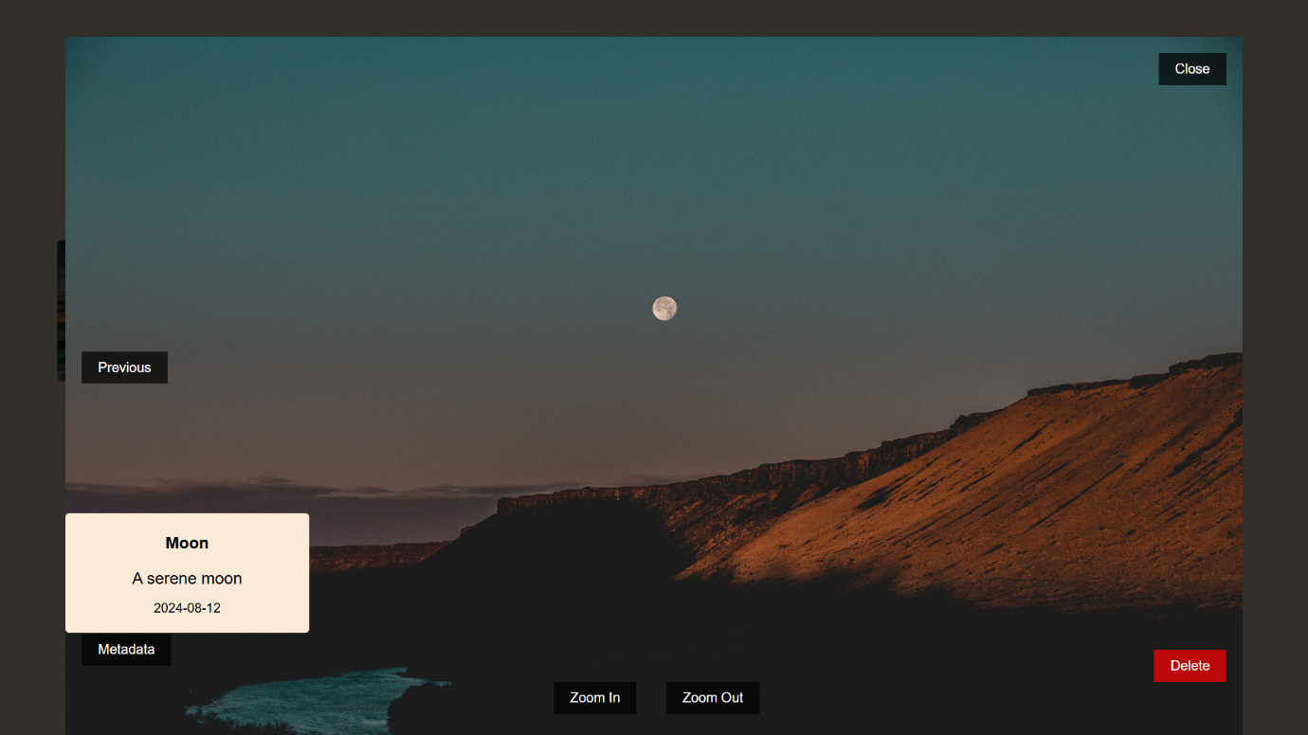Viewing the meta data information**:**

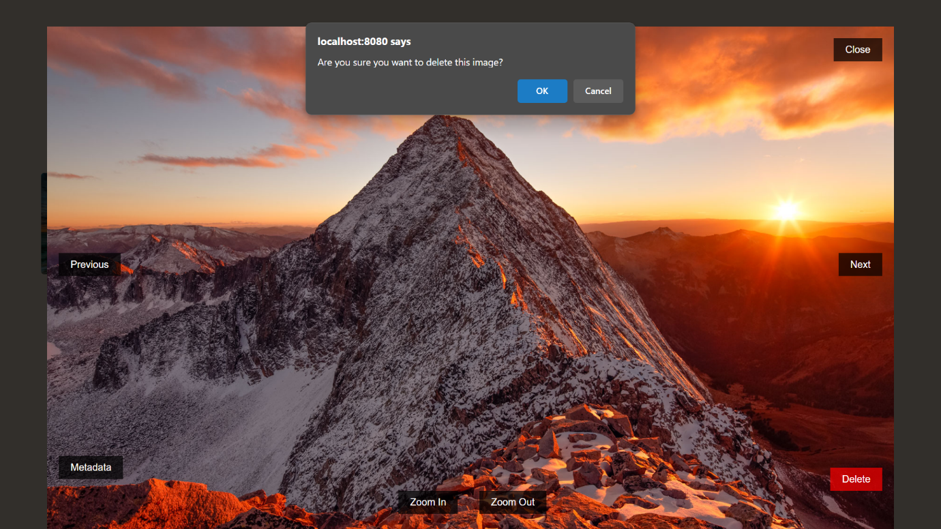Zoom in/ Zoom out Functionalities:

Deleting an Image: